**Keynote speech2**

Wind energy is the kinetic energy generated by the movement of air. Compared with solar energy, nuclear energy and other energy sources, wind energy is able to meet the demand of resource development due to its advantages such as continuous expansion of production scale, obvious advantages in conversion efficiency and rapid technological development. The global wind power generation industry has been a sunrise industry and developing rapidly with increasing production capacity.

Wind energy is characterized by the following features:

1. Abundant in resources and widely distributed
2. Cost-saving and easy to manufacture
3. Renewable and environment friendly

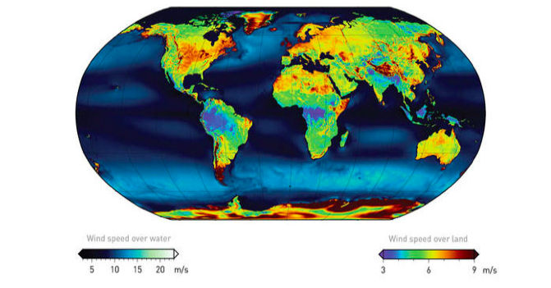

Figure. 1

Developing trends:

1. Improve utilization rate and reduce generation cost

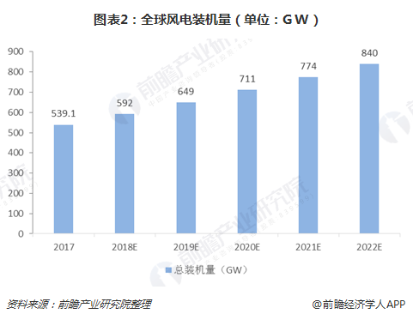

Figure. 2

Fig .2 illustrates the development trend of global wind power capacity from 2017 in which the capacity has been rising at a high speed. In addition to the available low-altitude wind resources mainly utilized nowadays, there are also high-altitude wind resources to be developed and used. In addition to natural wind energy, industrial wind energy wasted in industrial development should be fully utilized.

1. Increase the development of offshore wind power generation

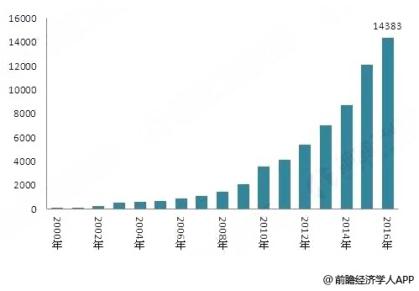

Figure. 3

From Fig .3 we can see that the offshore wind power is a new industry developing rapidly. Nowadays, the offshore wind power facilities are mostly built near the coast. In the future, wind power is bound to develop in the deep sea, which is more extensive, more abundant in wind energy and the wind speed is more stable for utilization.